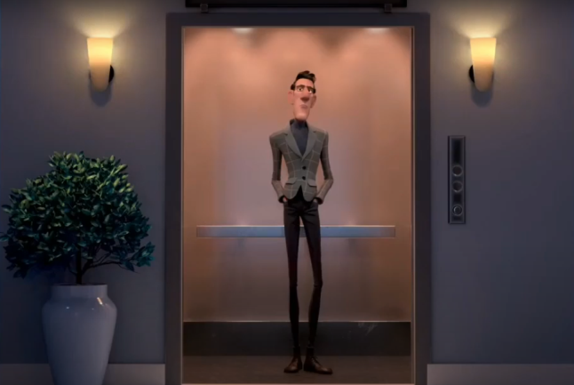**Before Watching**

1. Do you consider yourself as a helpful person? Why/Why not?

**Yes, because I help my classmates in the class or in the homework.**

1. Have you ever helped a stranger before? Tell the class!

**Yes, in Christmas I help a man with my father In pushing a car to turn it on.**

1. Have you ever been helped by a stranger before? Tell the class!

**Yes, In the road to the school I tripped over falling to the floor, then a lady came by and helped me**

1. **After Watching**

**Determine whether the following statements are TRUE or FALSE based on the short movie you just watched!**

1. The man meets the first lady on the stairs **(TRUE)**
2. The color of the balloon is green **(FALSE)**
3. The shopping cart is chased after by the owner **(TRUE**)
4. The “volunteer” lady is wearing a veil **(FALSE)**
5. Both the man and the old lady don’t know each other **(TRUE)**

**Identify the major plots of the story!**

1. Beginning:

**In the beginning the man didn't help anyone**

1. Main conflict:

**The man comes across an old woman who makes him reflect on how he is**

1. Ending:

**Man becomes a better person and seeks to return to others like the**

1. **Answer the questions based on your opinion!**
2. Why doesn’t the man help others in the beginning?

**Because the man doesn’t have empathy possibly because no one had thanked him**

1. What makes him finally wants to help the old lady?

**Because the old lady take he for the hand**

1. Why does he pretend to be blind?

**He wanted to turn that person into a kinder person.**

1. What is the best title for the movie?

**Little things**

1. What can you learn from the movie?

**I learn how the little things can met a lot**